**EXPERIMENT – 7**

**AIM: -** Write a program to implement flow control at data link layer using SLIDING WINDOW PROTOCOL. Simulate the flow of frames from one node to another.

**CODE: -**

# include <stdio.h>

int main()

{

int w,i,f,frames[50];

printf("Enter window size");

scanf("%d", &w);

printf("\n Enter %d frames:", f);

scanf("%d", &f);

printf("\n Enter %d frames:", f);

for (i=1; i<=f; i++)

scanf("%d", &frames[i]);

printf("\n With sliding window protocol the frames will be sent in the following manner (assuming no corruption of frames)\n\n)");

printf("After sending %d frames at each frames at each stage sender waits for acknowledement sent by the receiver \n\n", w);

for(i=1; i<=f;i++)

{

if(i%w==0)

{

printf("%d\n", frames[i]);

}

else

printf("%d\n", frames[i]);

}

if (f%w!=0)

printf("\n Acknowledgement of above frames sent is received by sender \n");

return 0;

}

**OUTPUT: -**

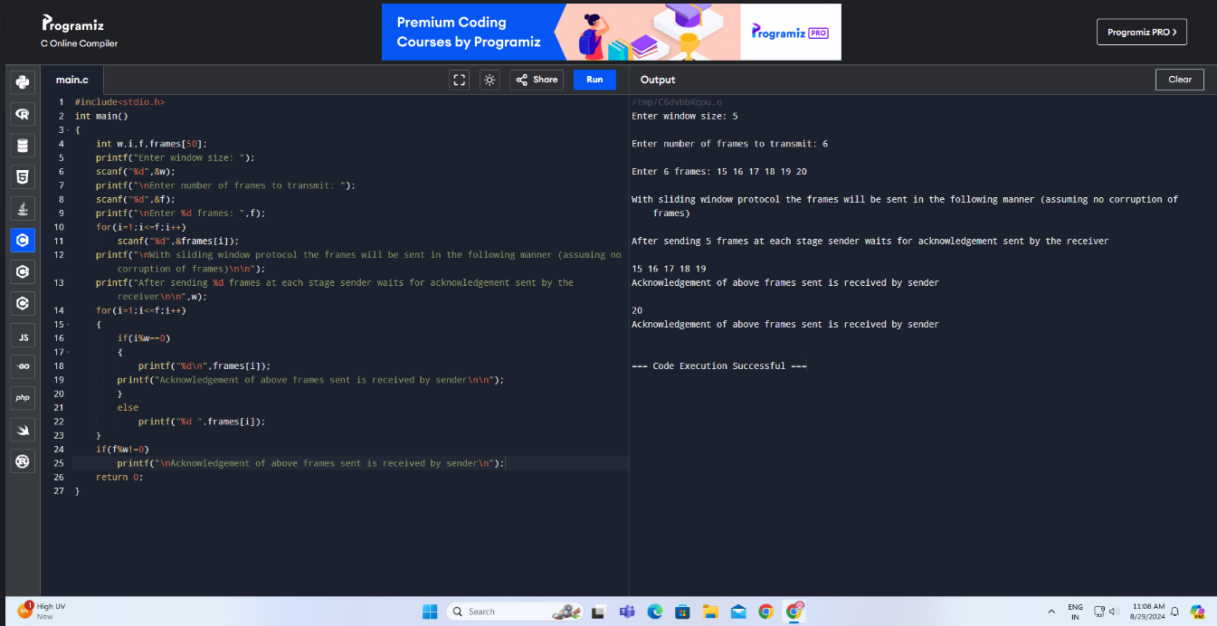

**RESULT: -**

The code for SLIDING WINDOW have been executed successfully and the output is verified.